**Summary**:

I found a nice explanation of the conical anamorphosis, and I think I understand how it works.

I’m still having difficulty with understanding the math of the projector camera, so I think it would be helpful if we could go over an example of it.

Conical anamorphosis explained in an easy way:

<http://www.grasshopper3d.com/forum/topics/conical-anamorphosis>

Daniel Piker wrote:

*“Place the original image below the cone,*

*take a line from the viewing point to each point of this image,*

*intersect these lines with the surface,*

*rotate each line 180° about the surface normal at the intersection point,*

*intersect the rotated line with the XY plane to get the transformed point.*

*No need to write any equations, and the nice thing about doing it this way is it is then trivial to use a different viewing point, or a different shaped mirror or image surface.”*

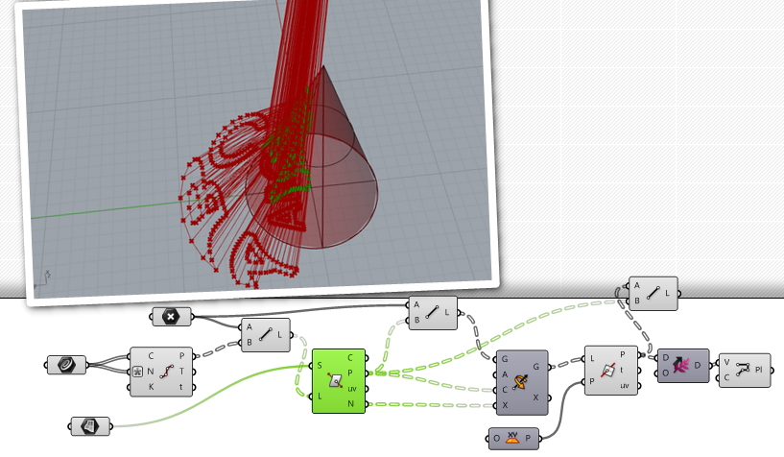

From last week:

Software for Windows to create oblique?, cylindrical mirror, conical mirror anamorphism:

<http://www.anamorphosis.com/software.html>

The Java version is not fully implemented yet and currently does not have the sanamorphism features.

<https://github.com/phillipkent/AnamorphMeIJ>

^Main website of that: <http://www.anamorphosis.com/index.html>

Millersville U, small experiment with cone anamorphism:

<http://www.millersville.edu/physics/experiments/079/index.php>